* Font: Verdana
* Preset amount buttons make color #C1DEFB
* When selected a preset amount make color ##3F98F1
* Change “confirm” button colour to #3F98F1
* If you enter another amount (not the preset amount) the pre-selected buttons become disabled (#C1DEFB)
* The final amount is not obvious – change the label to “I want to donate: $ 30”
  + Look to make this a fixed element (likely at the bottom)
* Need more white space between ‘Confirm’ and the text below (privacy policy)
* ‘Cover processing fee..’ and ‘by clicking I confirm…’ should not be the same size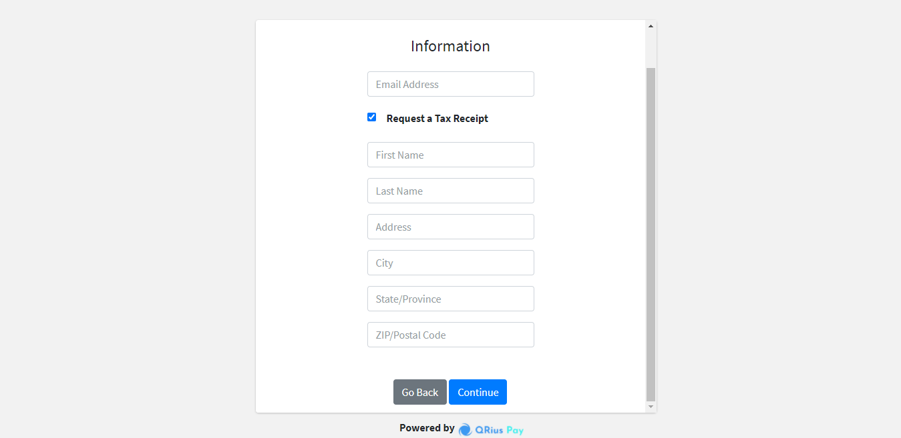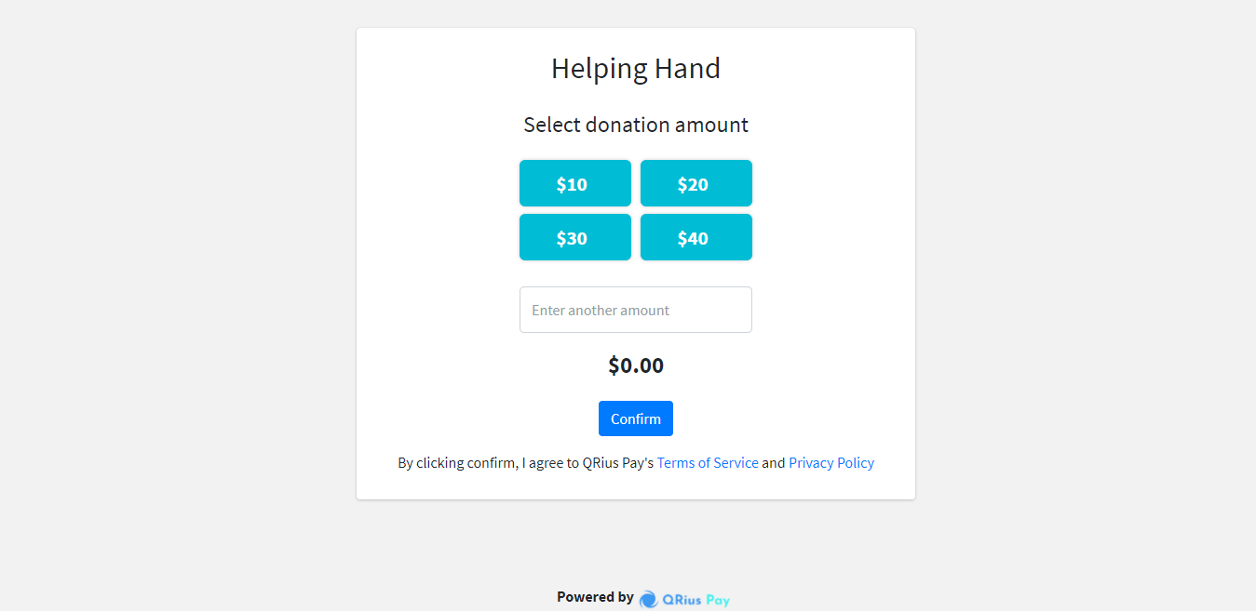

I want to donate $30

Select a Donation Amount

$10

$20

Other Amount

Cover the nonprofit payment processing fee

$40

By clicking confirm, I agree to QRius Pay’s Terms of Service and Privacy Policy

Helping Hand

Confirm

$30

* Font: Verdana
* labels above the fields
* Add a ‘Appt number’ field. This is an optional field
* Change “continue” button colour to #3F98F1
* Error messages should be clearer and should tell the user what they’re doing wrong, for instance

Continue

Information

Go Back

State

City

Address

Apt #

Last Name

First Name

**Request a Tax Receipt**

Email Address

**Credit Card**

* Font: Verdana
* Add final amount at the top
* Add a back button
* Change “Pay” button colour to #3F98F1

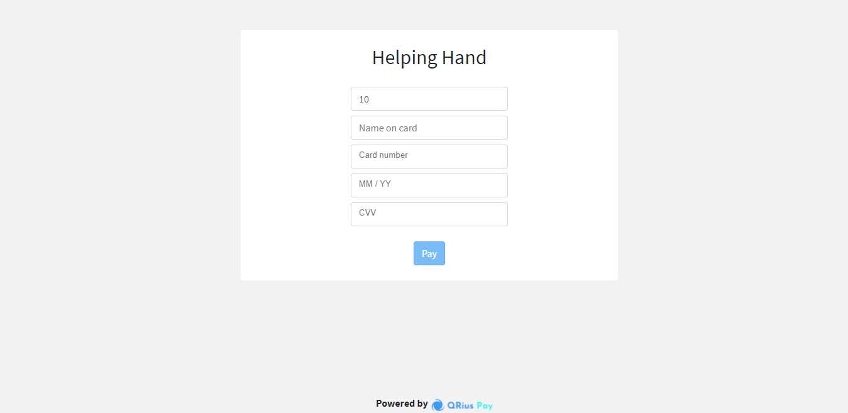

I want to donate

Card Information

$30

Name on card

Card Number

MM/YY

CVV

Go Back

Pay

* Font: Verdana
* Payment Success too close to header
* Tell the user that a copy of the transaction has been emailed to you
* Social media button should not be on background, they should be on a solid background (preferably white)
* Need to add ‘Share to tell other people to donate’ text to provide context to the social media buttons
* 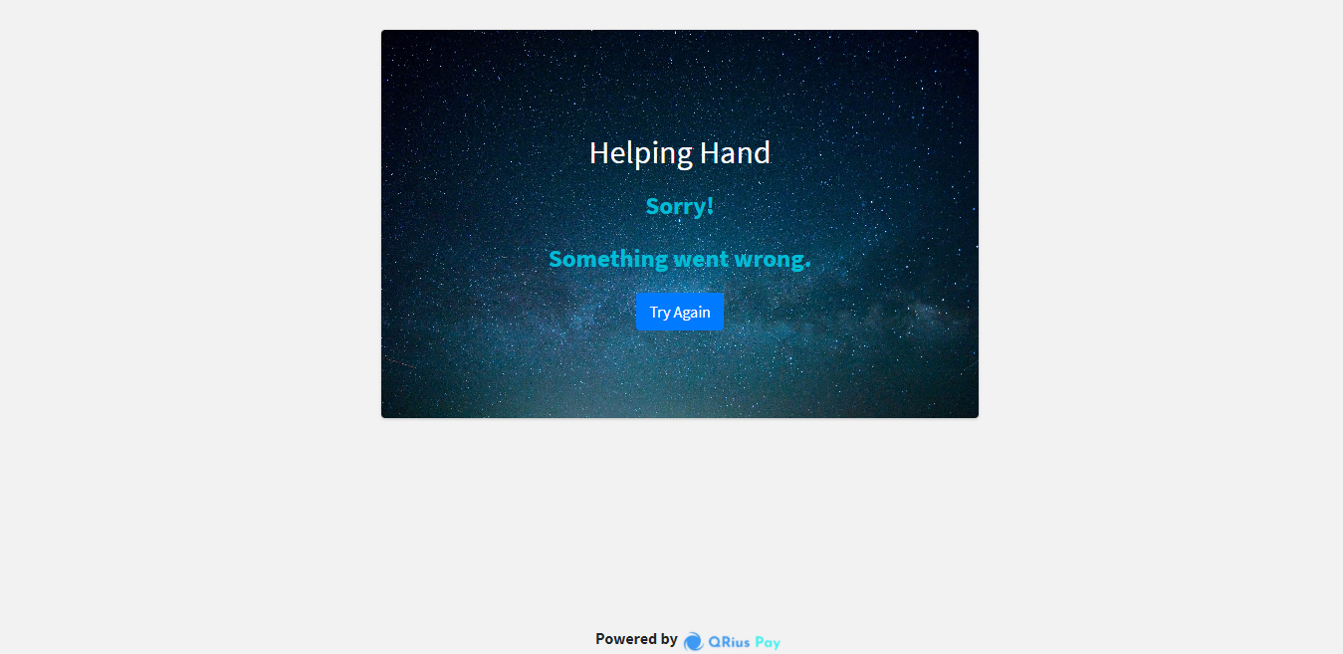

Thank you for your donation. A copy of the donation amount will be sent to your email

**Share to Invite Others to Donate**

Payment Success